1. **Machine Vision - Image Processing, Principle and Progressive part measurements**

Machine Vision, on a broader perspective, is the integration of cameras, sensors and image processing techniques to enable a computer to see, control, regulate, modify, simplify and enhance a process. It is widely prevalent technology employed in modern industries to implement automation in manufacturing and also in robotics. Apart from this there are widespread applications of Machine Vision.

The work presented here deals with the application of Machine Vision to make principle as well as progressive part measurements by modeling image acquisition, processing and measurement techniques in LabVIEW.

1. **Tools used for Processing - LabVIEW**

LabVIEW is a system-design platform and development environment for visual-graphical programming developed by National Instruments (NI). The non-text based graphical language is named as ‘G’. Its extensive applicability includes Data Acquisition, Data Analysis, Instrument Control, Industrial Automation, etc. NI-IMAQ, NI-Vision, NI-MAX and NI-DAQ are the tool kits, developed by NI for image processing, analysis and measurements, in LabVIEW.

1. **Image Processing, Analysis and Measurements**
   1. **Types of Images**

The general classification of image types are- Gray Scale, Color and Complex.

* + 1. **Gray Scale**- They contain X and Y spatial coordinates and their respective intensity values in the Z-direction (surface image). Image intensity data is represented by ‘depth’, which is the range of intensities per pixel. Generally, a bit depth of ‘x’ signifies image depth of 2x that means each pixel has an intensity value of 2x.
    2. **Color-** They are represented on RGB (Red Green Blue) or HSL (Hue Saturation Luminance) models. Hue signifies the actual color, Saturation signifies the amount of gray in the color and Luminance signifies the amount of black (or white) mixed in a color. These models are stored as 32 bit color images of four 8 bit channels. The representation of these models is done on a 0-255 scale.
    3. **Complex-** The complex representation includes real and imaginary parts. Image pixels are stored as a 64 bit floating point numbers (32 bit real and 32 bit imaginary). Complex images consist of frequency information representing a gray scale image. These images are created by performing Fast Fourier Transform (FFT) and can be converted back to original by reverse FFT.
  1. **Image Formats**

The image formatting is distinguished into two broad categories – Lossy and Lossless. Lossless formatting means effective reduction in size with efficient compression. Whereas, Lossy yields a degraded image with a loss of essential features. The most widely used image formats are JPEG (Joint Photographics Expert Group), TIFF (Tagged Image File Format), GIF (Graphics Interchange File), PNG (Portable Network Graphics), BMP (Bitmap), AIPD (a compressed format used internally by LabVIEW for floating points, complex and HSL along with calibration info) and others (.wmf-windows meta file, .ico-icon, .pcx-corporate pictures, etc).

* 1. **Bit Characterization of an Image**

Acquired images are referred to as 8 bit, 16 bit, 32 bit and so on. More the bit depth, higher is the accurate intensity measurements. Feature detection is possible with 8 bit image but accurate measurements require more than 8 bit. The bit characterization of an image plays a vital role in the feature detection of image processing. The raw image memory is dependent on the resolution as well as the bit depth.

Raw image memory = (Resolution)x * (Resolution)y * Bit Depth

* 1. **Image Measuring Methods**
     1. **Theoretical Approach**

The actual dimensions of the image can be calculated by determining the actual size per pixel of the image captured. The sensor size and pixel resolution would be specified in the data sheet of the OEM. From this information the actual size per pixel is determined. Owing to the existence of inactive sections between each of the CCD array elements of the detector, this approach is not adopted. A more feasible practical method of measurement is used.

* + 1. **Practical Approach**

The calibration of the camera, for the given working distance, is done with an object of known dimensions. By measuring the number of pixels the object occupies, the pixels occupied per unit measurement is determined. This is known as Pixel Size Coefficient. This ratio can be used to compute the size of any object provided it is at the same working distance.

Actual width of object = X units

Pixels occupied = Y pixels

Pixels per unit = X/Y units per pixel

* 1. **Hardware and setup**
     1. **Telecentric Optical Arrangement**

A standard lens generates different size images when changing the object-to-lens distance (e1 and e2 in Figure 1). In a telecentric lens arrangement, objects of different sizes would appear as if they had the same dimensions, provided they subtend the same viewing angle. The image is left unchanged with object displacement, provided the object stays within a certain range often referred to as depth of field or telecentric range.

In conventional optics, any geometric information that is parallel to the main optical axis also shows a component on the detector plane direction, while in a telecentric lens this perpendicular component is totally absent.

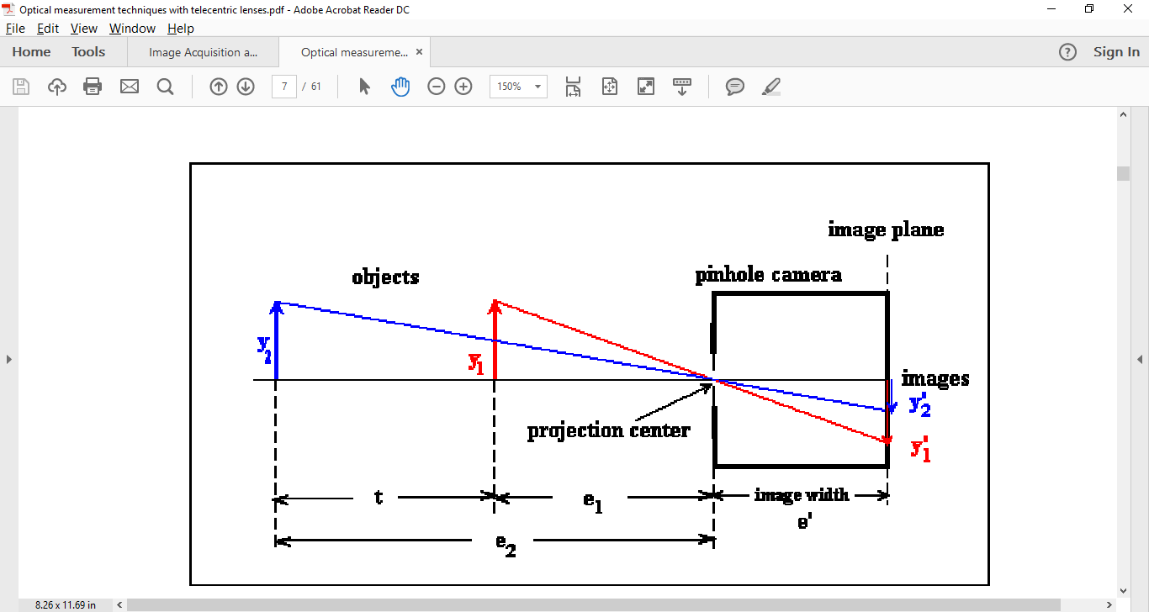

Figure 1: Conventional Optical Arrangement

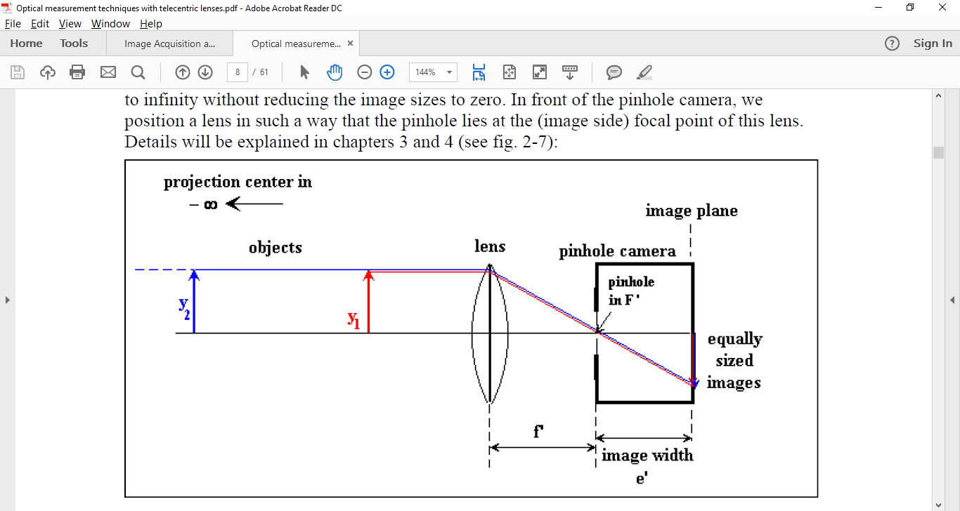

Figure 2: Telecentric Optical Arrangement

* + 1. **Test Bench Preparation – Hardware and Devices**

The Test Bench comprises of a Telecentric optical arrangement of Machine Vision GigE camera Basler acA780-75gc provided with an in-built Sony ICX415 CCD Image sensor and the Telecentric backlight illumination for the object identification is provided by Sill Telcentric LED condenser S6IRI1520/162. The optical arrangement is placed on a robust mechanical frame with adjustable NLM 21170 Joint heads mountings for the camera, condenser as well as object gripping platforms. The **Object Under Investigation (OUI)** is a mechanical component with three parallel spindles with ratchet knobs inscribed with a rotary scale on each knob. Each of the knobs can be rotated to achieve minute linear progressive dimensional change in the spindle. A linear scale is provided on each spindle for determining the distance moved linearly. The camera, the component and the condenser are arranged telecentric such that the three spindles lie in the focal region of the camera’s field of view. The camera and the condenser lens are both powered by a 12V DC power source.

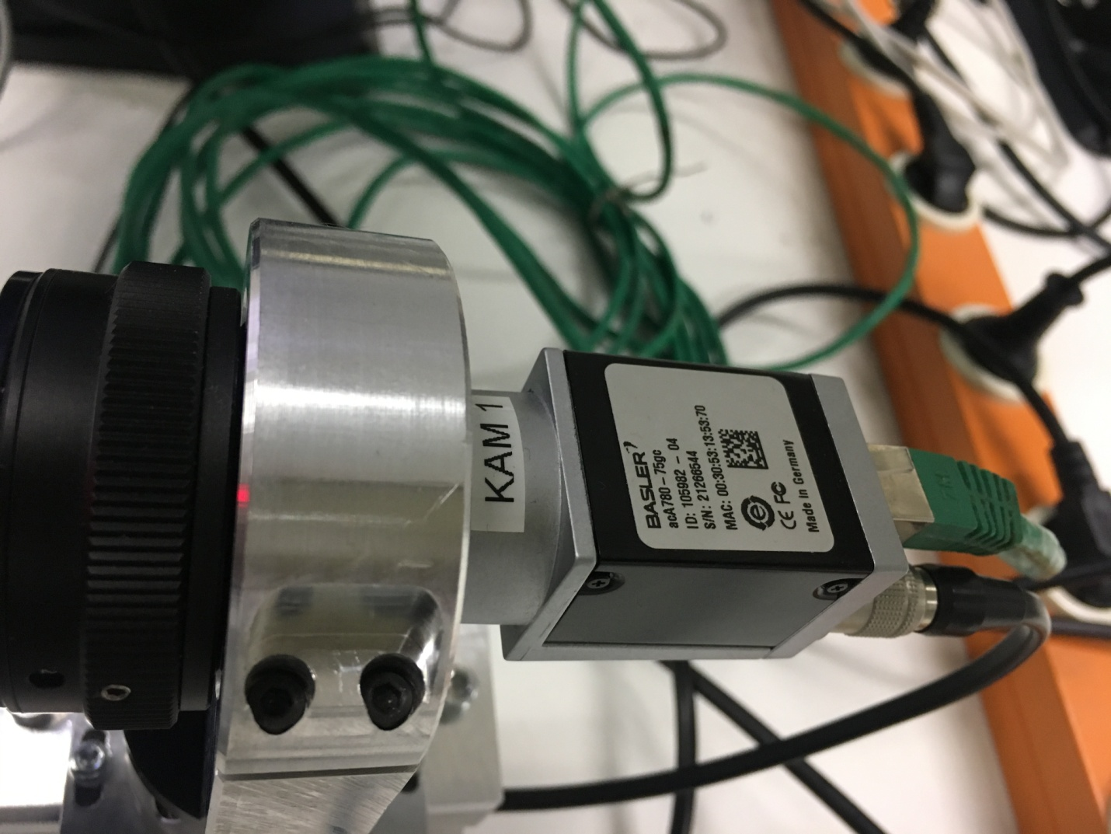

Figure 3: Machine Vision GigE camera Basler acA780-75gc

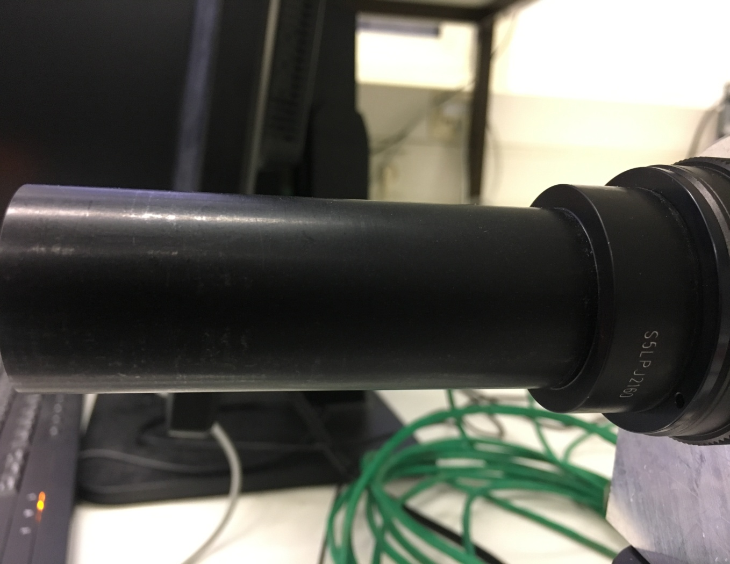

Figure 4: The Telecentric Lens for focusing object image onto the CCD array of sensor

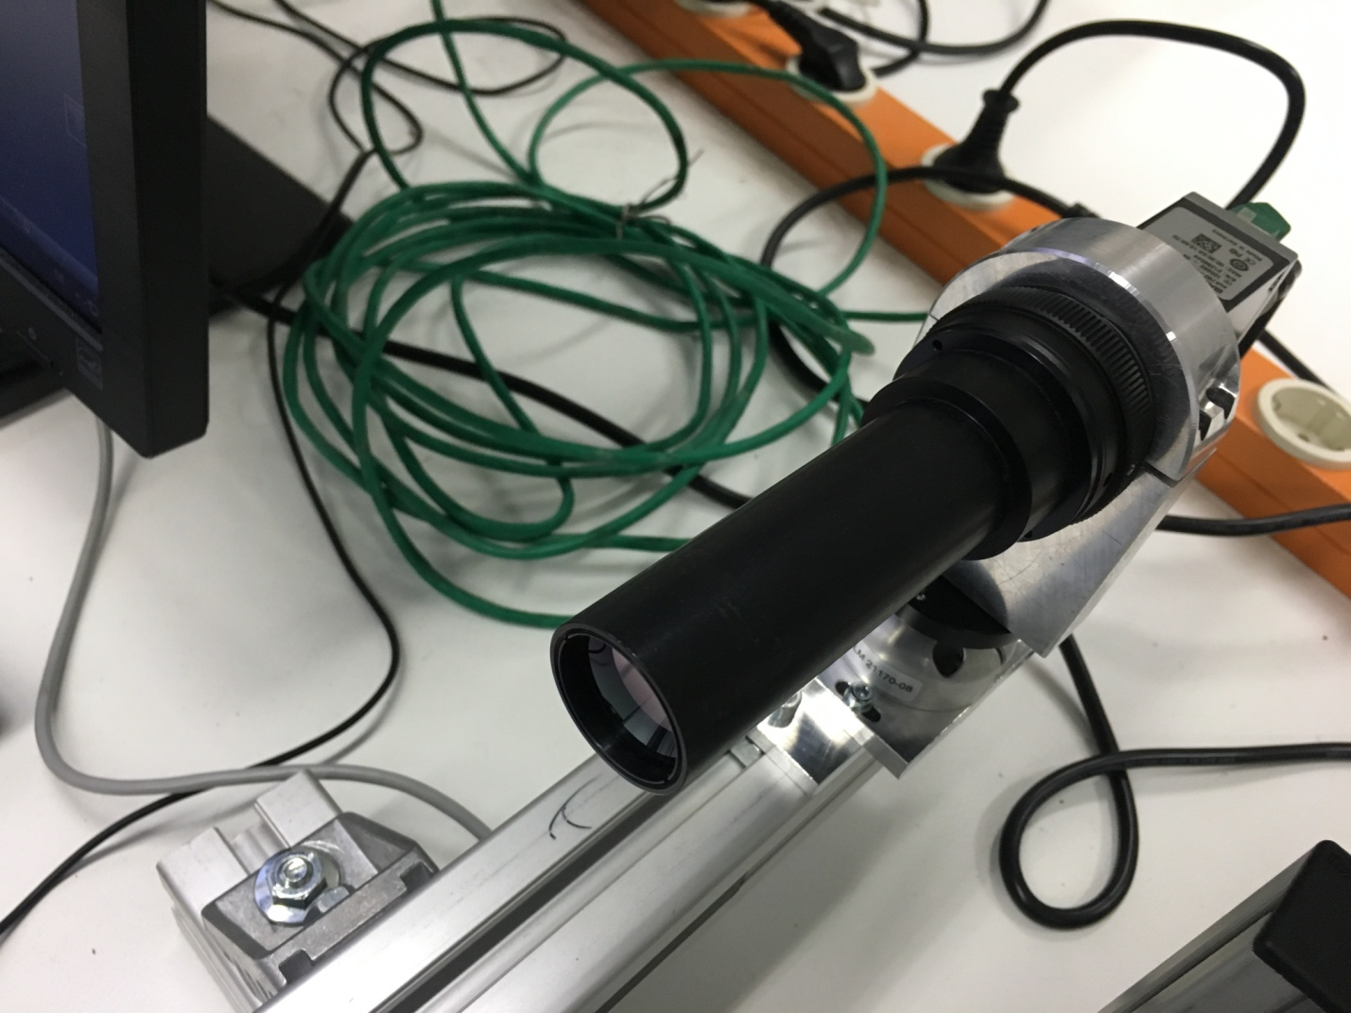

Figure 5: Telecentric Lens coupled to the camera

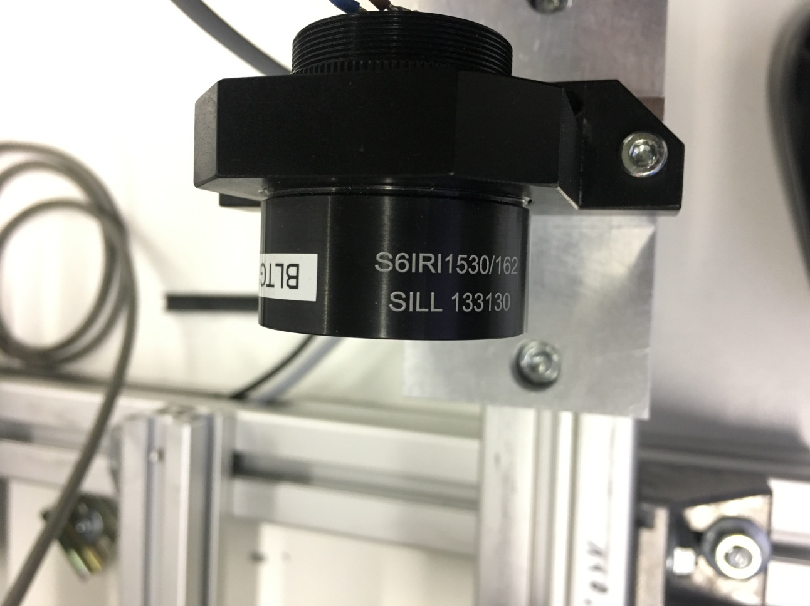 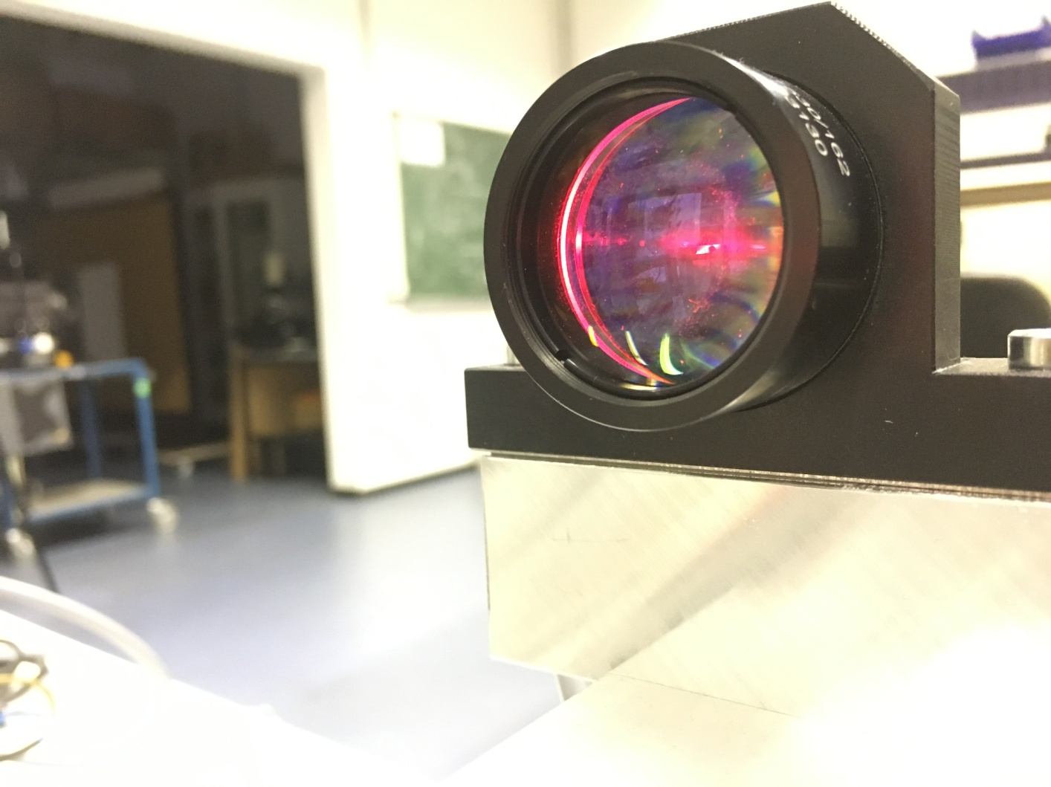

Figure 6: Telecentric backlight illumination by Sill Telecentric LED condenser S6IRI1520/162

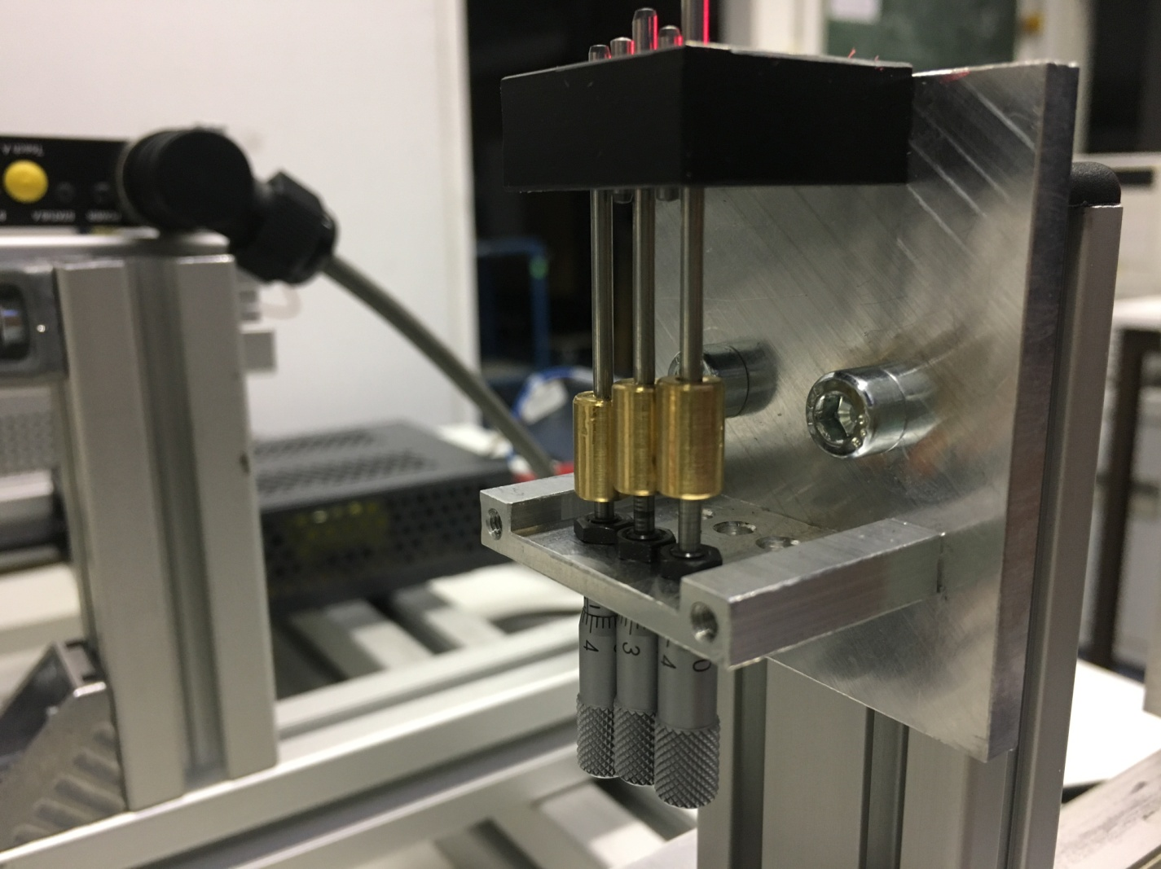 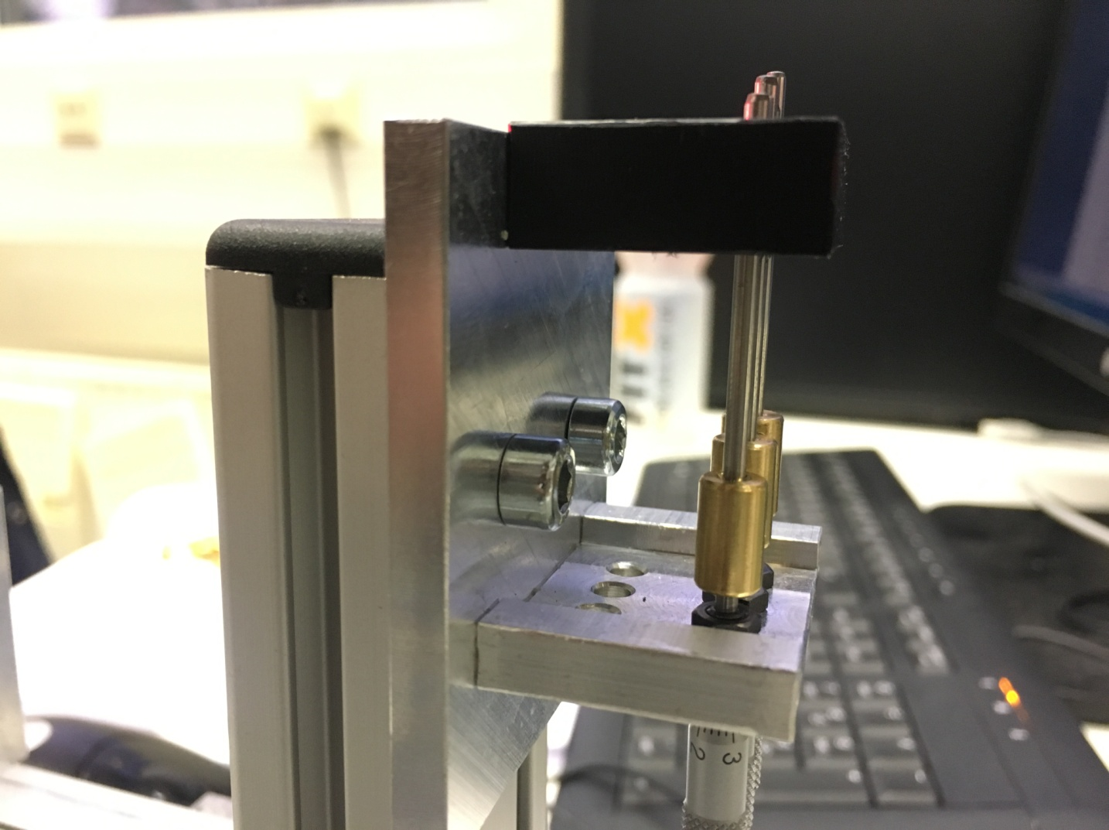

Figure 7: Object Under Investigation-Spindles with ratchet knobs with a linear and circular scale, respectively

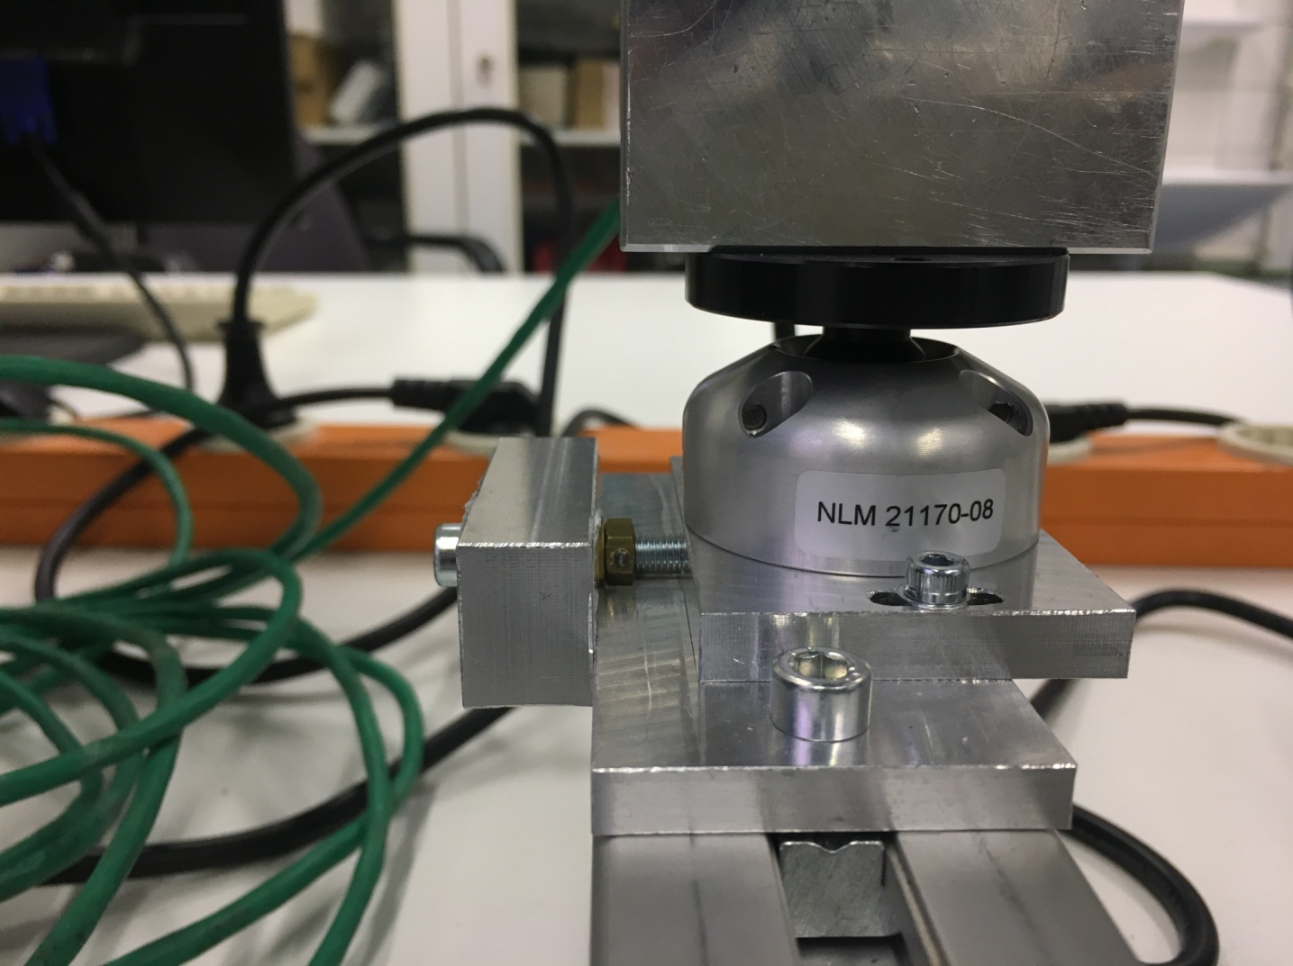

Figure 8: The camera system mounting-NLM 21170 Swivel Joint head

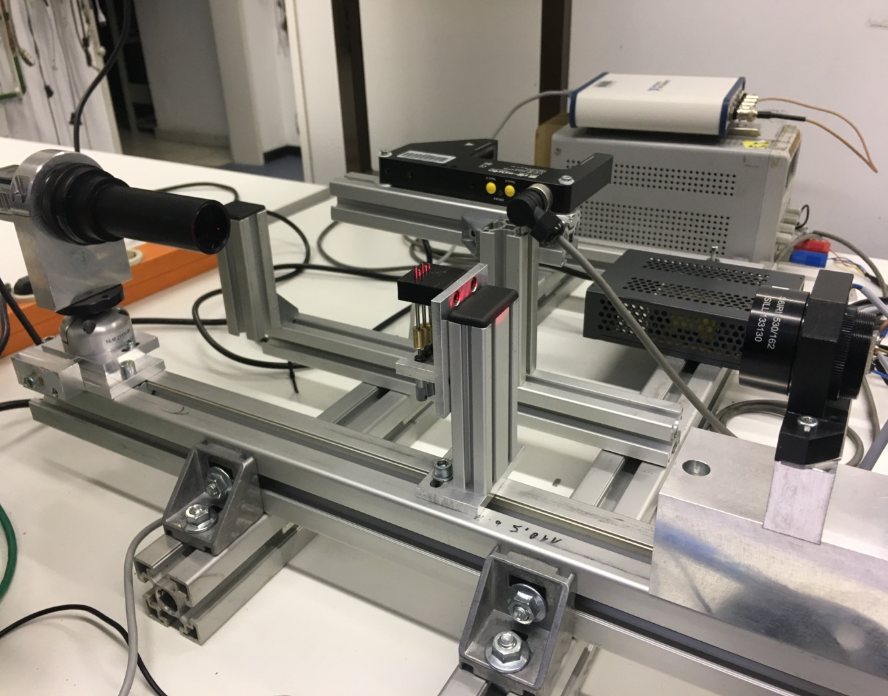

Figure 9: The test bench - Telecentric Optical Arrangement

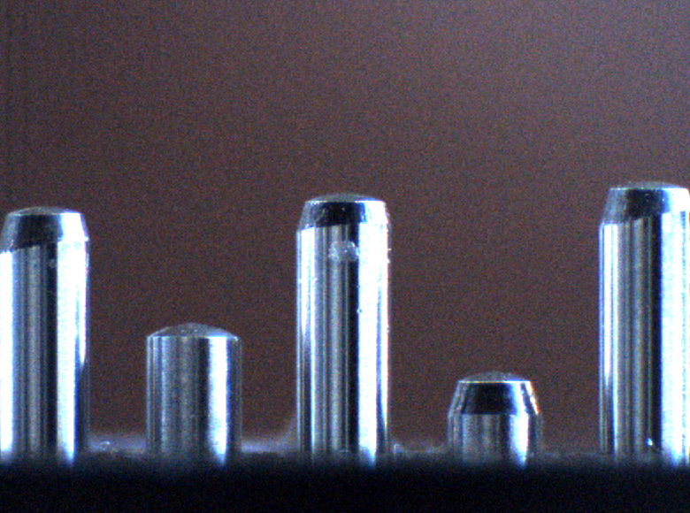

Figure 10: The Object Under Investigation(OUI)-captured with the camera system

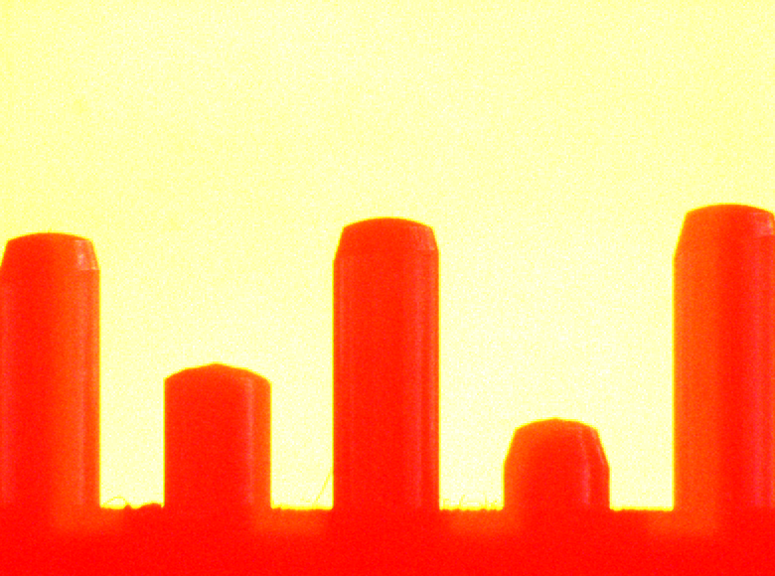

Figure 11: Image of OUI with the telecentric backlight illumination

* 1. **Calibration of the setup**

The calibration of the optical acquisition is done manually using Gauge Blocks (Slip Gauges). These are a standardized industrial calibration for measuring equipment. A gauge block of known dimension is mounted on the focal plane of the camera and the image is captured. This image is processed and the size of the image in pixels is recorded. The pixel size coefficient of the acquisition arrangement is determined by the process described in 3.4.2 of this document. Since the pixel is a square pixel (aspect ratio is 1:1), the size coefficient is same for horizontal and vertical measurements. The product of this pixel size coefficient and the number of pixels an object feature occupies, yields the actual dimension of the object under investigation in real world units.

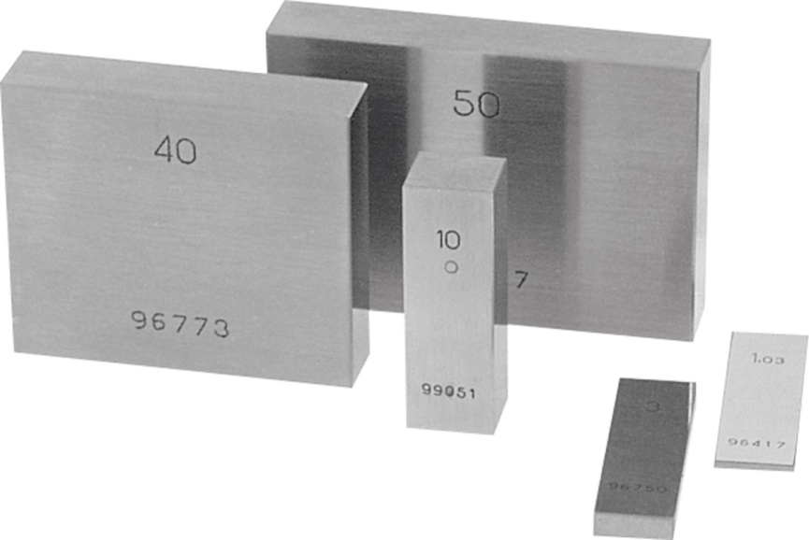

Figure 12: Slip Gauges-Measuring standards for calibration of image acquisition

* + 1. **Resolution**

Resolution can be defined as the smallest feature of an object that a camera system can detect and record. Resolution plays a vital role in selection of the camera. If the resolution is less then important information would not be recorded and a high resolution system is slower and would require more processing power as well as cost effective.

Taking into account the inactive sections on image sensor CCD array, the least resolution of a sensor is two pixels (minimum 2 pixels so that the image is not missed due to focusing on the inactive regions). The minimum sensor resolution can be determined by using the following relation:

Sensor Resolution =

* + 1. **Depth of field**

Depth of field is a range perpendicular to the lens within which the object remains in focus. For a telecentric optical arrangement the depth of field is very small. Only within this range a clear image without any distortions can be obtained. The following images from the telecentric optical arrangement under study illustrate how the object image is affected when the focal distance is changed by adjusting the focal length of the lens. *(Images yet to be added)*

* 1. **Image Acquisition**

The image acquisition unit Basler acA780-75gc is an area scan GigE interface camera with Sony ICX415 CCD Image sensor that has the ability to deliver a frame rate of 75 frames per second with CCIR resolution. CCIR stands for Consultative Committee for International Radio which establishes standard for image acquisition that uses interlaced scan technique to reproduce the captured image of the object under investigation.

The scan types of image acquisition devices can be broadly classified into three groups- Progressive Area Scan, Interlaced Area Scan and Line Scan. Progressive Scan is used when the object is under motion and a clear image has to be acquired. In this application, the object under investigation is relatively stationary at the point of acquisition and hence an area scan camera would be sufficient for the study. The camera employed here uses an interlaced area scan to generate the image.

* 1. **Image Processing**

The image processing comprises of the series of operations performed to achieve a desired output on the image obtained after the acquisition. The image acquired from the camera system is a raw image of RGB 32 bit format. Image manipulations are generally performed on a binary image rather than a RGB image. The luminance plane is extracted from the captured image and converted to a grayscale image. The histogram for the generated grayscale image is plotted and the limits for pixel values are determined. These limits are applied as the range for threshold process and the binary transformation of the grayscale image is performed. The binary image with clear edges is obtained and the height of the spindle in pixels is measured.

The OUI are spindles with ratchet knobs. The linear progression of the spindle can be adjusted by these knobs. A minimum linear variation of 5mm can be obtained by rotating the knob and the maximum is 40mm. The image of the three spindles is acquired, saved and processed to obtain the height in pixels. This pixel measurement is converted to microns by multiplying with the pixel size coefficient obtained during calibration. The spindle length is varied periodically and a comparison is made between the actual dimensional change to the dimension obtained from image acquisition algorithm developed in LabView. An inference can be made about the dimensional accuracy of image processing technique in performing principle measurements.

* 1. Image Analysis

Disturbances in image processing

Noise in an image-types of noise

Pixel aspect ratio and Pixel Accuracy

Threshold -Conversion to a binary image

Measurements

* 1. **Algorithm for Image Processing**

1. Setup of Hardware, Devices, Software Requirements/Configurations
2. Optical Arrangement-Telecentric Optical Setup
3. Calibration of the optical setup
4. Describe Object Under Investigation (OUI)
5. Using NI-MAX configure the camera and verify the image acquisition type
6. LabView Programming starts
7. Verify if camera is active and selected or else ask user for camera selection
8. After selecting the camera, start the image acquisition
9. Capture the raw image in RGB 32 bit format and save it as a new file into a folder with a name format. Either prompt the user to select a particular folder for image writing or directly provide a predefined constant file path for image writing.
10. Convert the image to a gray scale image by extracting the luminance plane and then transform the image to binary format with a predefined range for the binary scale transformation.
11. Fix a datum line for making measurements with respect to that line
12. Measure the number of pixels the Object Under Investigation (OUI) is above the datum line(height of object from datum)
13. Convert this to a standard measurement scale(mm)
14. Save the image as a new file into a folder with a name format as well as the measurement information into an excel sheet. Either prompt the user to select a particular folder for image writing or directly provide a predefined constant file path for image writing.
15. Continue this process until the user asks to exit
16. Display a report comprising of the periodic changes in the height of the OUI from the cycle start time to end time and also ask the user if the data needs to be stored or not
    1. **Implementation**
       1. **LabView VIs**

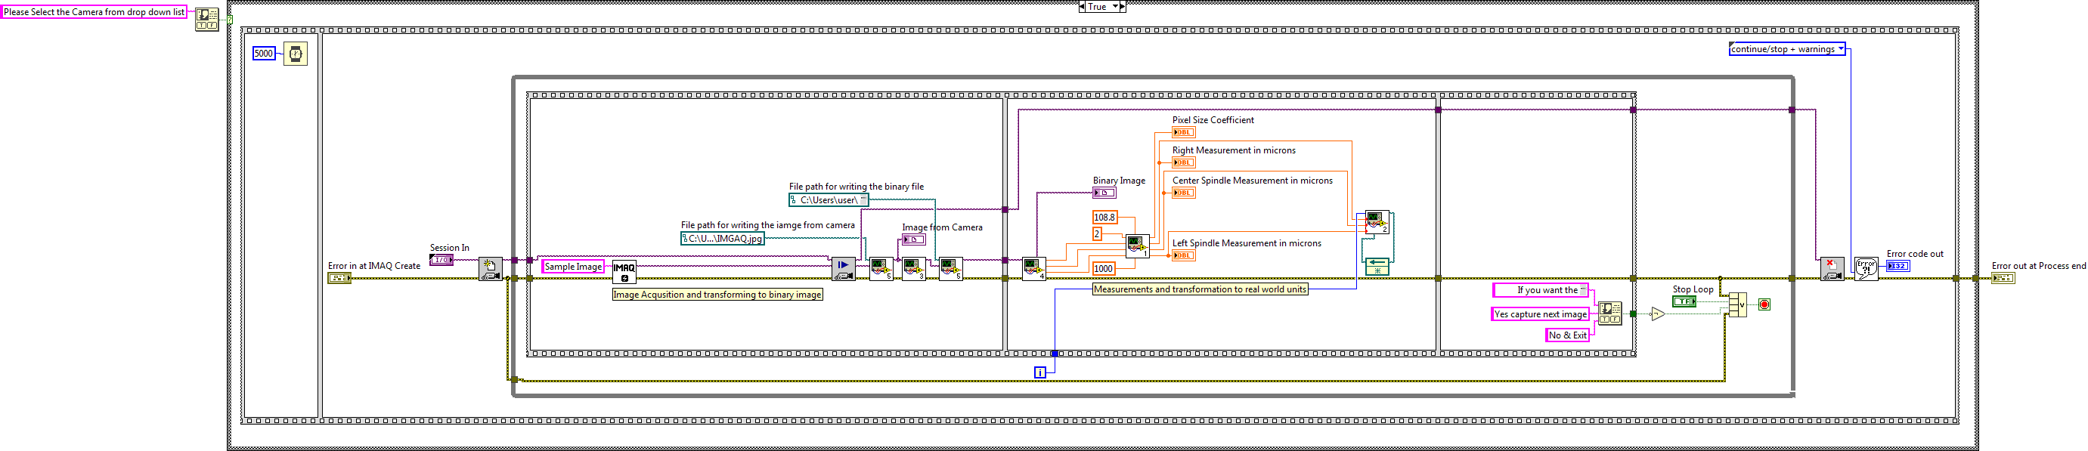

Figure 13: VI for image acquisition and measurement

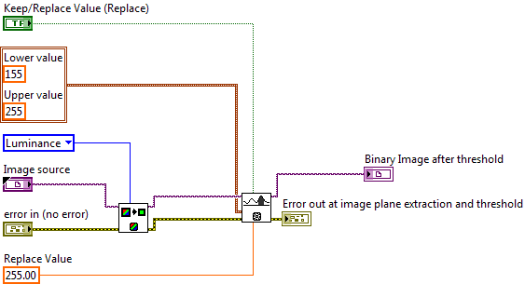

Figure 14: VI for transformation of an image to binary image

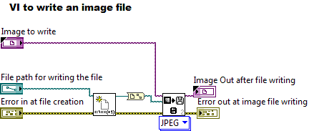

Figure 15: VI for saving an image

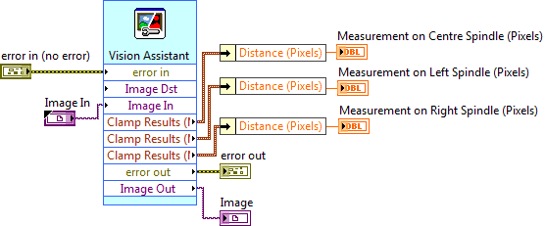

Figure 16: VI for measuring the height of the OUI

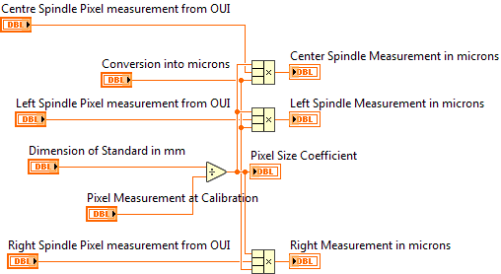

Figure 17: VI to convert the image measurements into real world units

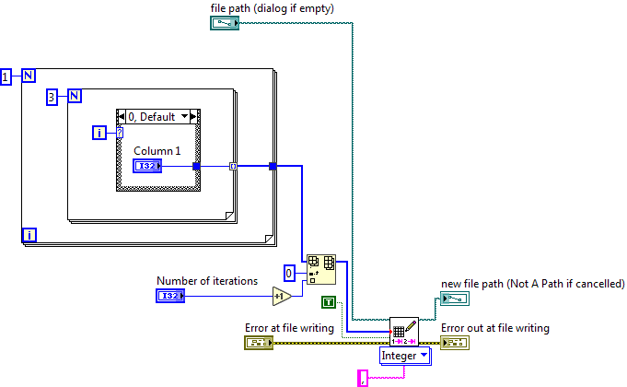

Figure 18: VI to tabulate the image measurements in a spreadsheet file

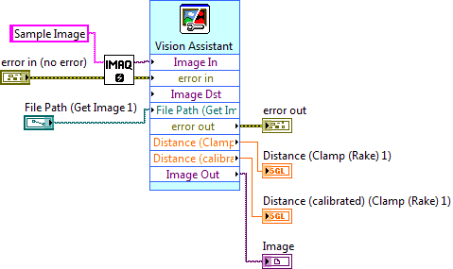

Figure 19: Express VI used for calibration

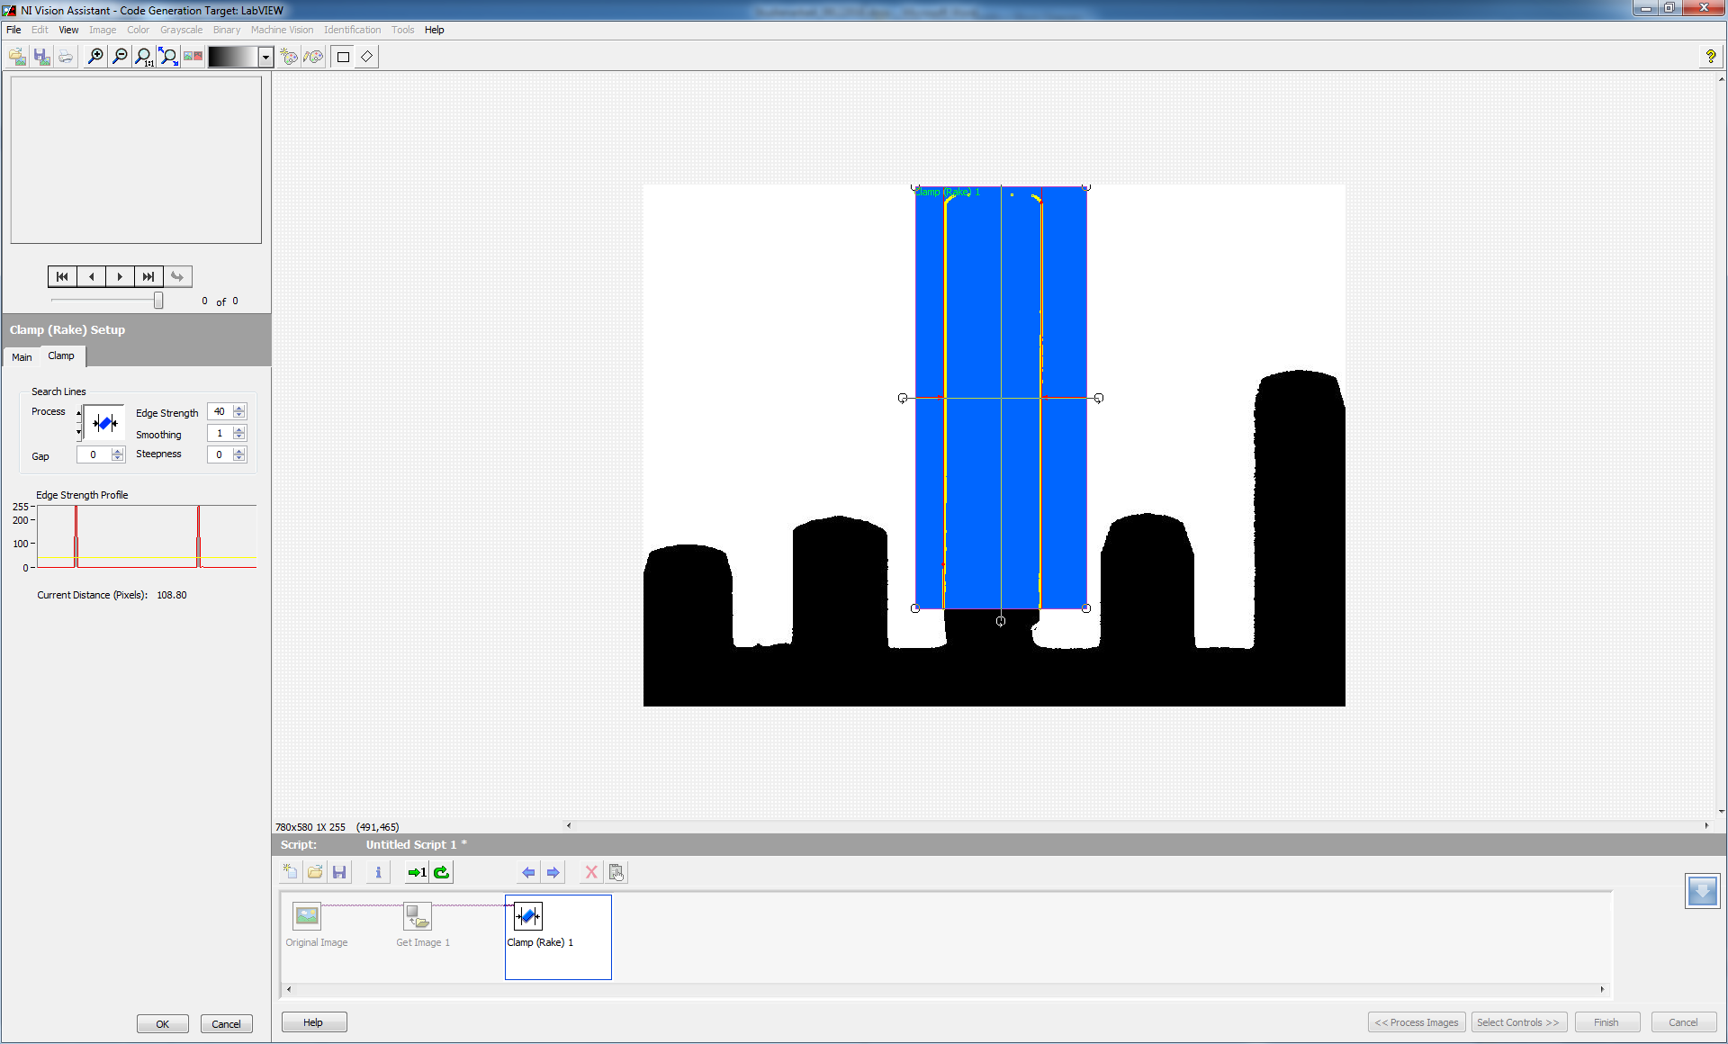

Figure 20: The blocks used in Express VI mentioned in Figure 19

* + 1. **Calibration**

The calibration of the image acquisition is done by first capturing the image of a standard slip gauge of 2mm width and then transforming it to a binary image by threshold operation. The pixels occupied by the object in the image is measured and then the pixel size coefficient is determined. The following illustration explains this process step by step.

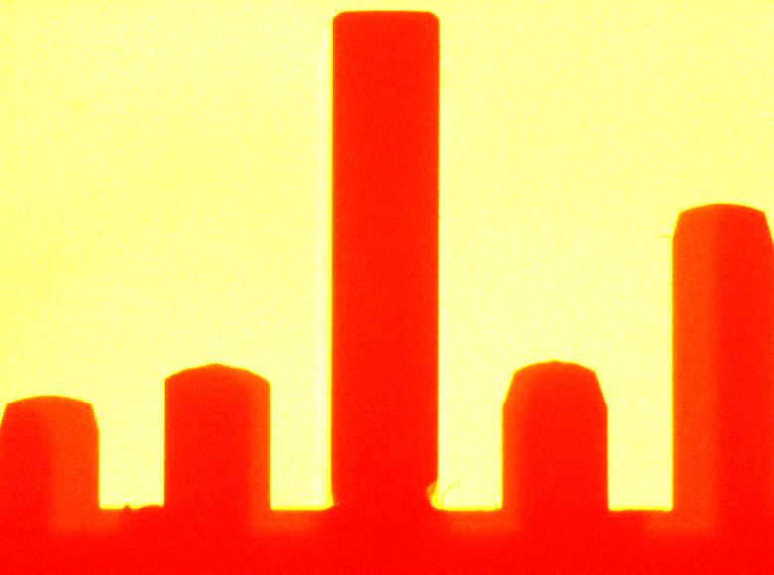 

Figure 21: The RGB image is the image acquired from the camera and the image adjacent to this is the binary transformation of the RGB 32 bit image to an 8 bit image

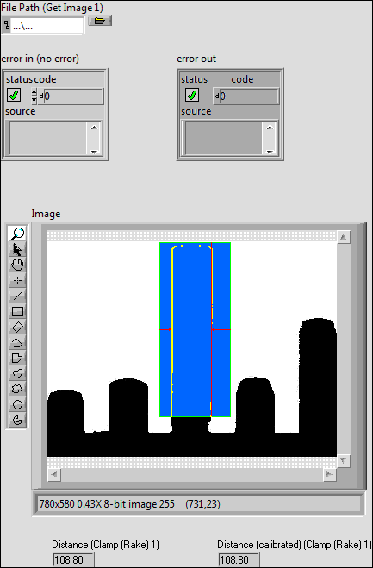

Figure 22: The VI front panel measures the width of the standard slip gauge and returns it as Distance

Actual width of object = X units = 2mm =2000µm

Pixels occupied = Y pixels = 108.80 pixels

Pixels per unit = X/Y units per pixel = 0.018382353 mm/pixel

**Pixel Size Coefficient** = 0.018382353 mm/pixel **(or)** 18.38235294 µm/pixel

* + 1. **Object Under Investigation and Principle Measurements**

The LabView VI shown below shows the front panel with the acquisition source, image acquired and then its binary transformation and then the measurement of the heights from the base of the OUI. The image is saved and also the measurements are written to a spreadsheet and the subsequent measurements are appended to the same spreadsheet file.

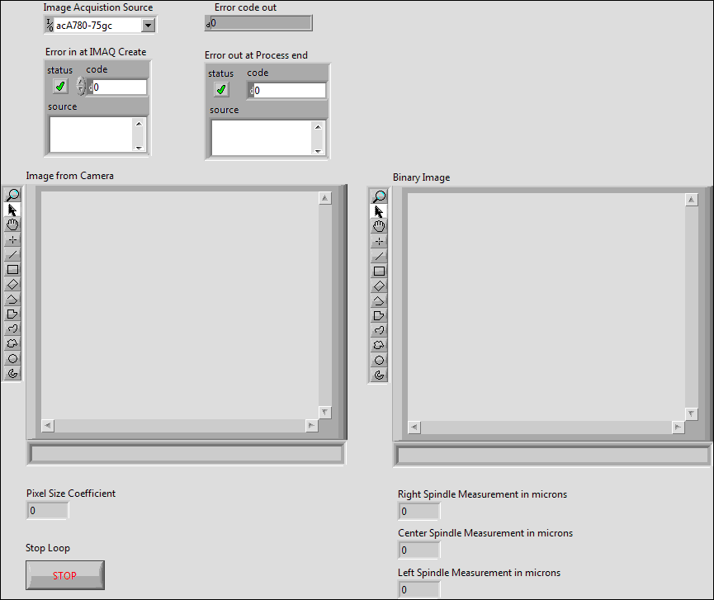

Figure 23: The front panel of the VI used for image measurements before acquisition begins

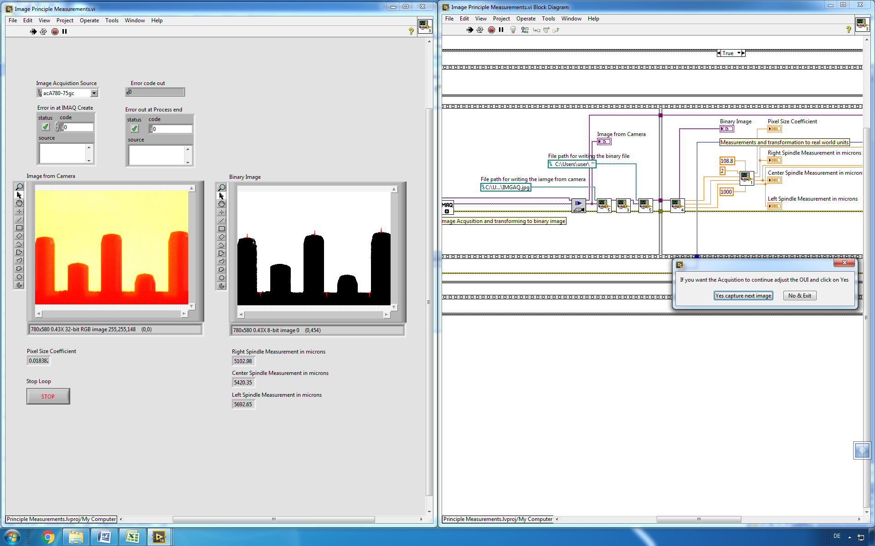

Figure 24: The front panel of the VI after acquisition and the heights of the three spindles is displayed in microns(µm)

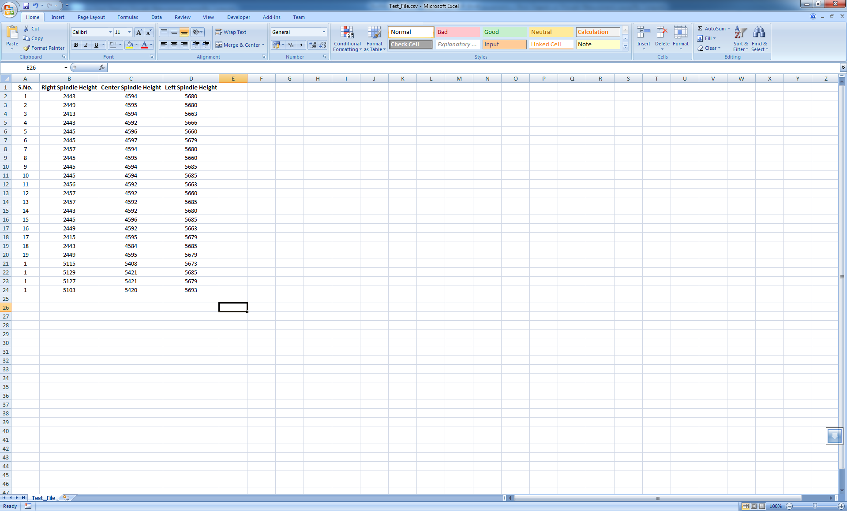

Figure 25: The acquisition is continuous and the values are written to a spreadsheet file for further processing

* 1. **Scope of future work**
* The next stages in this study would comprise of measuring the variation of the height periodically and the tabulated data is compared to the actual change in the dimension of the height when adjusted manually.
* The measurement information can be saved with a time stamp and the image location such that the image as well as the data can be reviewed anytime.
* The fork light barrier will be configured and programmed in LabView in such a way that it detects the object movement when the user changes the height by rotating the ratchet knobs.
* Establishing an interpreting medium between the image acquisition device and data acquisition module such that an inference can be made about the test bench setup.
* Identification of disturbances, enhancements to the threshold process and binary transformation, improving the pixel accuracy and standardization of the measurement process.